**P87**

第1题

代码：x=(-6:0.1:6)*pi;y=sin(x)./x; plot (x,y)

x=(-6:0.1:6)*pi+eps;y=sin(x)./x; plot(x,y)

图像：

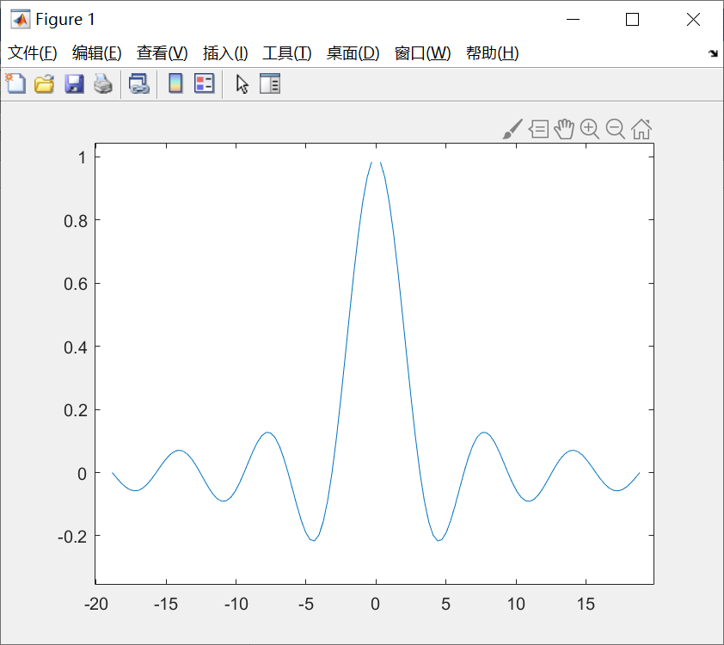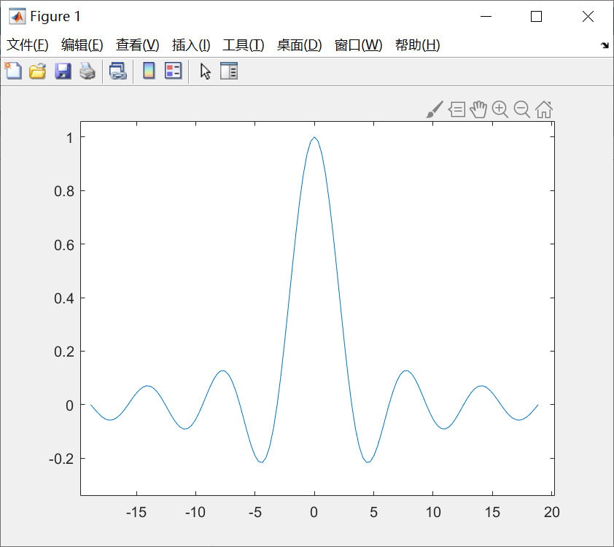

两幅图的区别是，在X=0这一点出时，函数值一幅存在，另一幅不为存在，因为eps 是MATLAB定义的一个很小的非零常数，它的用途就是避开分母中的零值，所以第二幅图在x=0处图像存在。

第2题：

代码：

t=(0:0.03:2)*pi;y1=t.^2;y2=-(t.^2);y3=sin(t).*t.^2;

plot(t,y1,t,y2,t,y3);

图像:

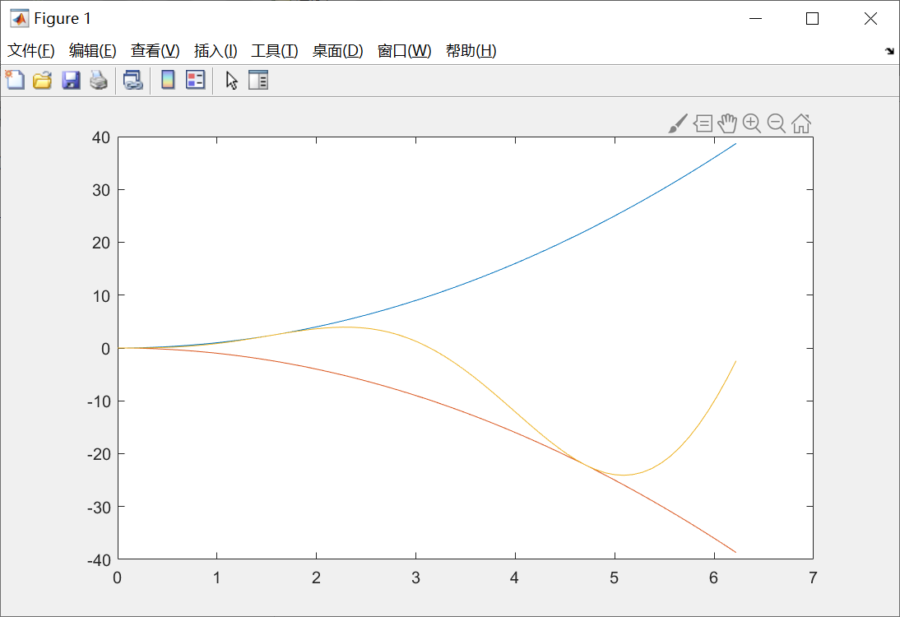

第3题

代码：

t=(0:0.03:2)*pi;y1=t.^2;y2=-(t.^2);y3=sin(t).*t.^2;

plot(t,y1,'--r',t,y2,'-.g',t,y3,'*')

grid on, xlabel(‘时间’), ylabel('幅值')

图像：

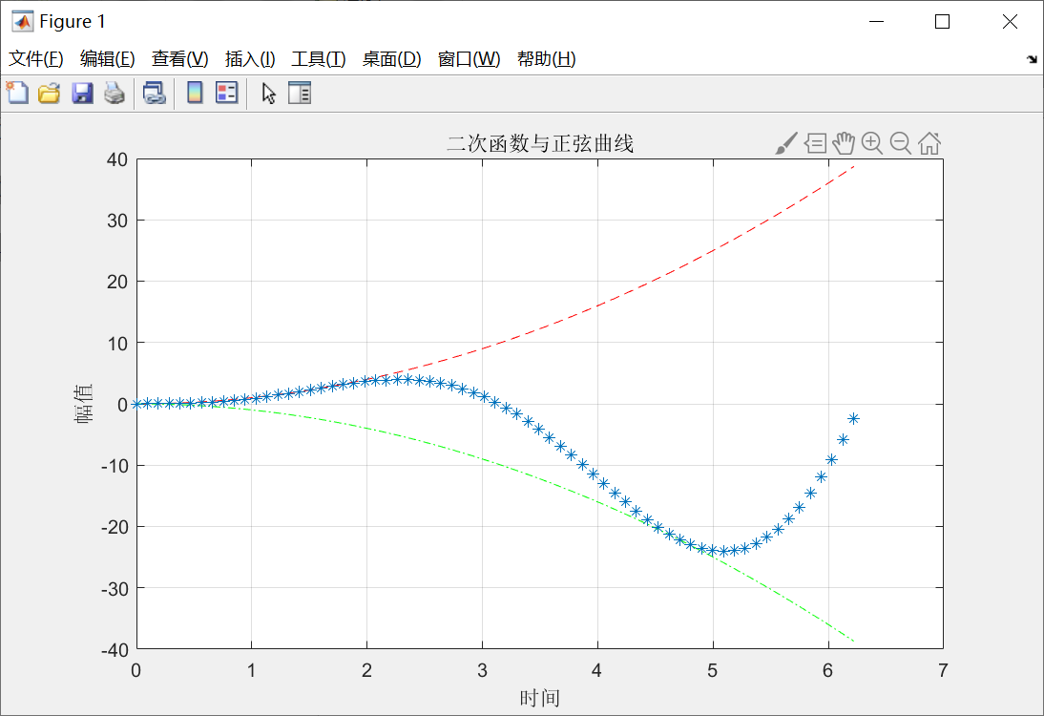

第4题

代码：

theta=0:0.1:8*pi;

subplot(2,2,1),polar(theta,1.0013*theta.^2,'--r');

subplot(2,2,2),polar(theta,cos(3.5*theta),'b');

subplot(2,2,3),polar(theta,sin(theta)./theta,'g');

subplot(2,2,4),polar(theta,1-cos(7*theta).^3,'-.c')

图像：

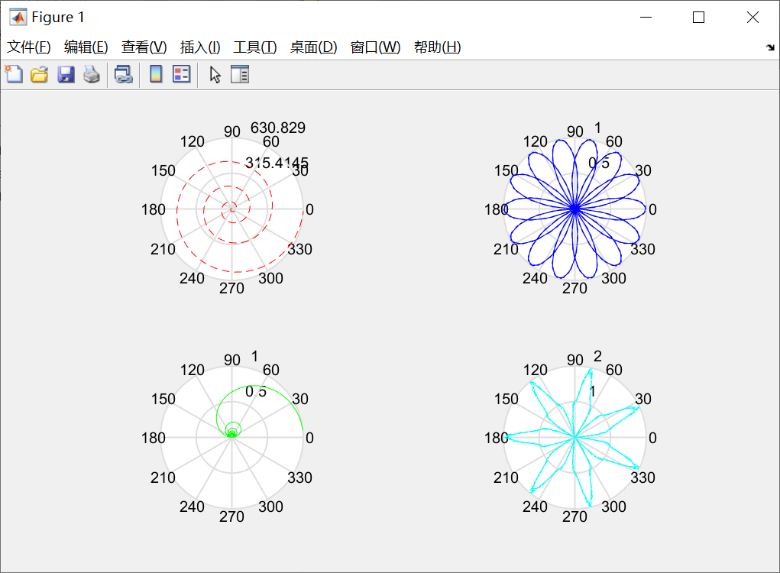

第5题

代码：

[x,y]=meshgrid(-15:0.5:15,-15:0.5:15);

R1=sqrt((1-x.^2)+y.^2);

R2=sqrt((1+x.^2)+y.^2);

z = 1./R1 + 1./R2;

z(imag(z)~=0) = NaN;

subplot(2, 2, 1);

mesh(x, y, z);

xlabel('x');

ylabel('y');

zlabel('z');

title('Three-dimensional surface');

subplot(2, 2, 2);

mesh(x, y, z),view(0,0)

colorbar;

title('主视图');

subplot(2, 2, 3);

mesh(x, y, z),view(-90,0)

colorbar;

title('左视图');

subplot(2, 2, 4);

mesh(x, y, z),view(0,90)

colorbar;

title(‘俯视图’);

图像:

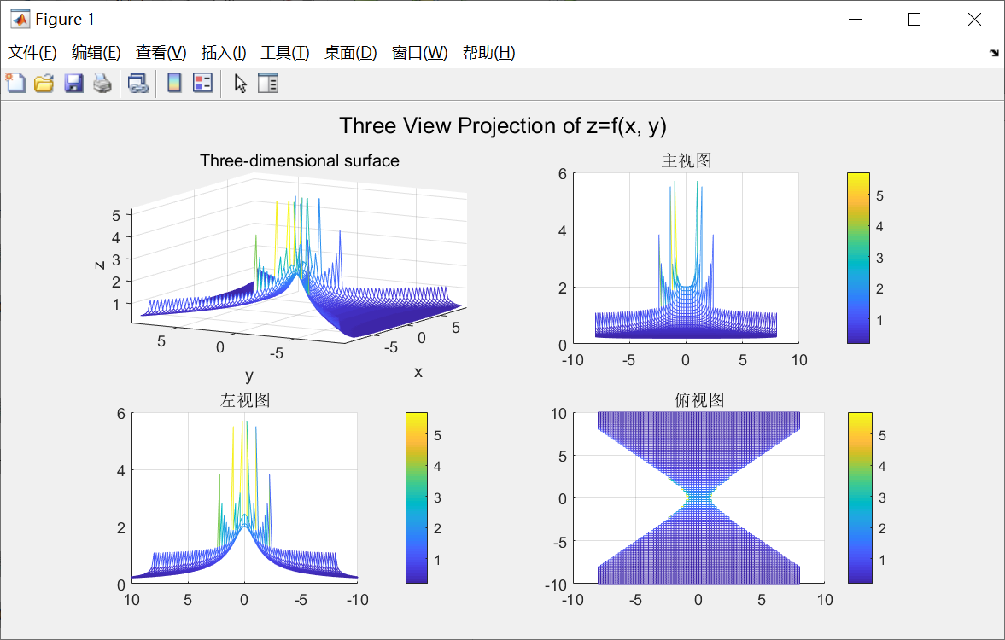

第6题

代码：

figure;

plot(0,0);

axis([-10 10 -10 10]);

box off;

points = ginput(5);

x_values = points(:, 1);

for i = 1:5

text(points(i,1),points(i,2),num2str(points(i,1)), 'VerticalAlignment', 'bottom', 'HorizontalAlignment', 'right');

end

hold on;

plot(points(:, 1), points(:, 2), 'r', 'LineWidth', 2);

hold off

图像：

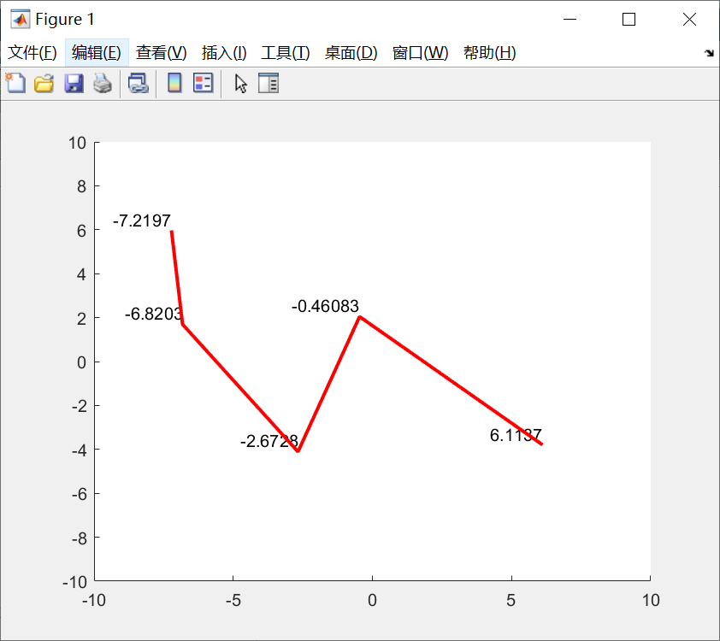

第7题：

代码：

load('workspace.mat', 'y');

% 计算采样频率

Fs = 1 / 0.01;

N = length(y);

f = -Fs/2 : Fs/N : Fs/2 - Fs/N; % 频率轴范围为[-Fs/2, Fs/2)

% 创建图形窗口并布局

figure;

% 绘制波形图

subplot(2, 2, 1);

plot(y);

title('Waveform');

xlabel('Time (s)');

ylabel('Amplitude');

% 绘制幅频图

subplot(2, 2, 2);

Y = fftshift(fft(y));

Y_mag = abs(Y);

plot(f, Y_mag);

title('Magnitude Spectrum');

xlabel('Frequency (Hz)');

ylabel('Magnitude');

% 绘制相频图

subplot(2, 2, 3);

Y_phase = angle(Y);

plot(f, Y_phase);

title('Phase Spectrum');

xlabel('Frequency (Hz)');

ylabel('Phase (rad)');

图像：

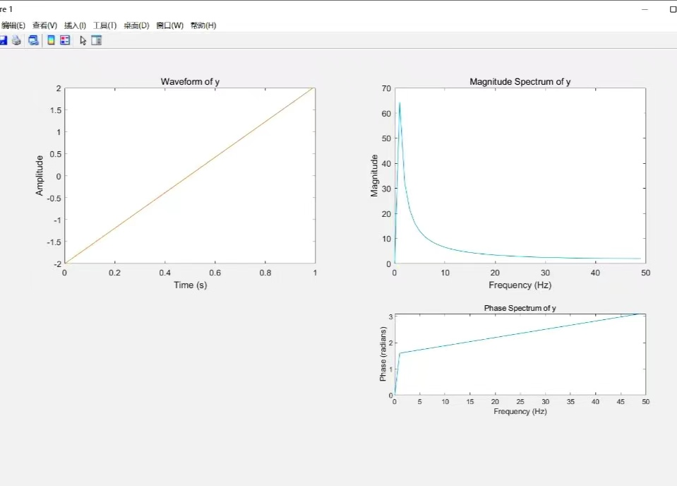

第8题

代码：

t = 0:1/1000:1-1/1000;

signal = 12*sin(2*pi*10*t) + 5*cos(2*pi*40*t);

noise = randn(size(t));

mixed_signal = signal + noise;

figure;

subplot(2,1,1);

plot(t, mixed_signal);

title('时域波形图');

xlabel('时间(s)');

ylabel('幅值');

fft_signal = abs(fft(mixed_signal, 1024));

frequencies = linspace(0, 1000, 1024);

subplot(2,1,2);

plot(frequencies, fft_signal);

title('幅频图');

xlabel('频率(Hz)');

ylabel('幅值');

图像:

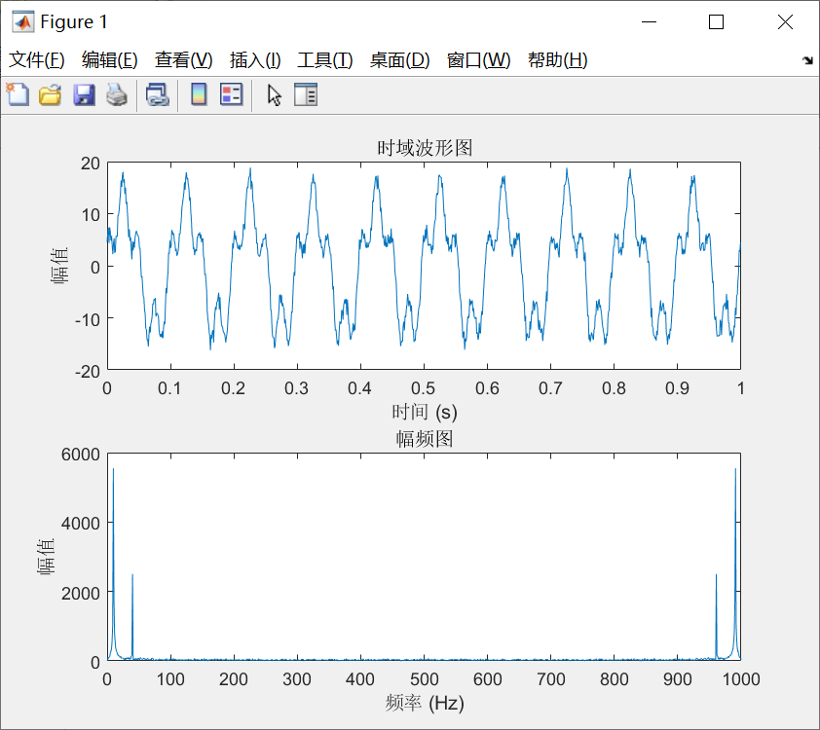

第9题：

代码：

img = imread('logo.jpg');

hFig = figure('Position', [0, 0, 700, 600]);

imshow(img, 'InitialMagnification', 'fit');

text(10, 10, '欢迎使用MATLAB', 'FontSize', 14, 'Color', 'white', 'FontWeight', 'bold');

movegui(hFig, 'southwest');

Matlab实例：频谱、功率谱和功率谱密度计算作业

代码：

%信号参数

FWHM = 50e-12; %宽度

t_center = 2.5e-9; % 中心点(s)

window_width = 100 * FWHM; % 采样窗口宽度

N = 2048; % 采样点数

dt = window_width / N;

t=(-window_width/2:dt:window_width/2-dt)+t_center; % 时间点

sigma = FWHM / (2 * sqrt(2 * log(2))); % ±ê×¼²î (s)

gaussian_signal = exp(-0.5 * ((t - t_center) / sigma).^2);

amplitude_spectrum = abs(fftshift(fft(gaussian_signal)));

phase_spectrum = angle(fftshift(fft(gaussian_signal)));

two_sided_power_spectrum = abs(fftshift(fft(gaussian_signal))).^2;

two_sided_power_spectral_density = two_sided_power_spectrum / (N * dt);

one_sided_power_spectrum = two_sided_power_spectrum(1:N/2+1);

one_sided_power_spectral_density = two_sided_power_spectral_density(1:N/2+1);

power_spectrum_W = one_sided_power_spectrum / (N * dt);

power_spectrum_mW = power_spectrum_W * 1000;

power_spectrum_dBm = 10 * log10(power_spectrum_mW / 0.001);

% 绘制幅度谱

figure;

plot(t, amplitude_spectrum);

title('Amplitude Spectrum');

xlabel('Time (s)');

ylabel('Amplitude');

grid on;

% 绘制相位谱

figure;

plot(t, phase_spectrum);

title('Phase Spectrum');

xlabel('Time (s)');

ylabel('Phase');

grid on;

% 绘制双边功率谱

figure;

plot(t, two_sided_power_spectrum);

title('Two-sided Power Spectrum');

xlabel('Time (s)');

ylabel('Power');

grid on;

% 绘制双边功率谱密度

figure;

plot(t, two_sided_power_spectral_density);

title('Two-sided Power Spectral Density');

xlabel('Time (s)');

ylabel('Power Spectral Density');

grid on;

% 绘制单边功率谱

figure;

plot((0:N/2) * (1/window_width), one_sided_power_spectrum);

title('One-sided Power Spectrum');

xlabel('Frequency (Hz)');

ylabel('Power');

grid on;

% 绘制单边功率谱密度

figure;

plot((0:N/2) * (1/window_width), one_sided_power_spectral_density);

title('One-sided Power Spectral Density');

xlabel('Frequency (Hz)');

ylabel('Power Spectral Density');

grid on;

图像：

